**VeriFone USB Driver Installation Guide**

July 13, 2012



Table Of Content

1 Introduction 3

2 Types of Installation 3

2.1 USB Driver Installation 3

o Standard Installation 3

o Using Installer 3

o Manual Installation 3

2.2 USB Driver Un-Installation 3

3 Standard Installation 3

3.1 Steps for Installation 3

3.2 Steps for Un-installation 3

4 Advanced Installation 4

4.1 Installation Using Installer 4

4.2 Manual Installation using device manager 4

5 USB Driver Un-installation 6

5.1 Normal Un-installation 6

6 Clean-up previously installed driver: 7

7 Disabling Auto-update Option on WIN 7 10

8 Toggle Zero Writes 12

9 Com Port Properties 12

# Introduction

This document details the procedure to install and uninstall VeriFone USB Driver. It covers both standard installation and installation for the advanced users. This VeriFone USB Driver installation supports Vx terminals on WIN 7 and WIN XP platforms.

# Types of Installation

The following section describes the different type of installations.

## USB Driver Installation

### Standard Installation

### Using Installer

### Manual Installation

## USB Driver Un-Installation

# Standard Installation

This section describes the standard installation procedure of USB driver.

## Steps for Installation

1. Download the zip file that is provided.
2. Extract the contents of the zip file to c:\usbdriver.  Create a folder **usbdriver**, if does not exists.
3. Open a command prompt.
4. Switch to **c:\usbdriver** directory.
5. Ensure that the device is unplugged from the PC.
6. Run **silent2.bat /com90**

|  |  |
| --- | --- |
|  | The user can provide the required COM port as a parameter. If the port is not mentioned then the installation takes the default port as COM9. |

1. The driver will be installed without any UI.   Wait for the installation to complete.
2. Connect the terminal/PINpad using USB and power up the terminal.

## Steps for Un-installation

1. Exit all the application that is using COM port.
2. Open a command prompt.
3. Switch to **C:\Program Files\VERIFONE\Vx USB Driver** directory.
4. Run   
   **C:\Program Files\VERIFONE\USB Driver\unins000.exe /silent**.

# Advanced Installation

This section describes the installation procedure for advanced options.

## Installation Using Installer

1. Run the setup.exe and follow the instructions to install the driver.
2. While installing the driver, place the driver files to the default installation folder, “**C:\Program Files\VERIFONE\USB Driver**”.

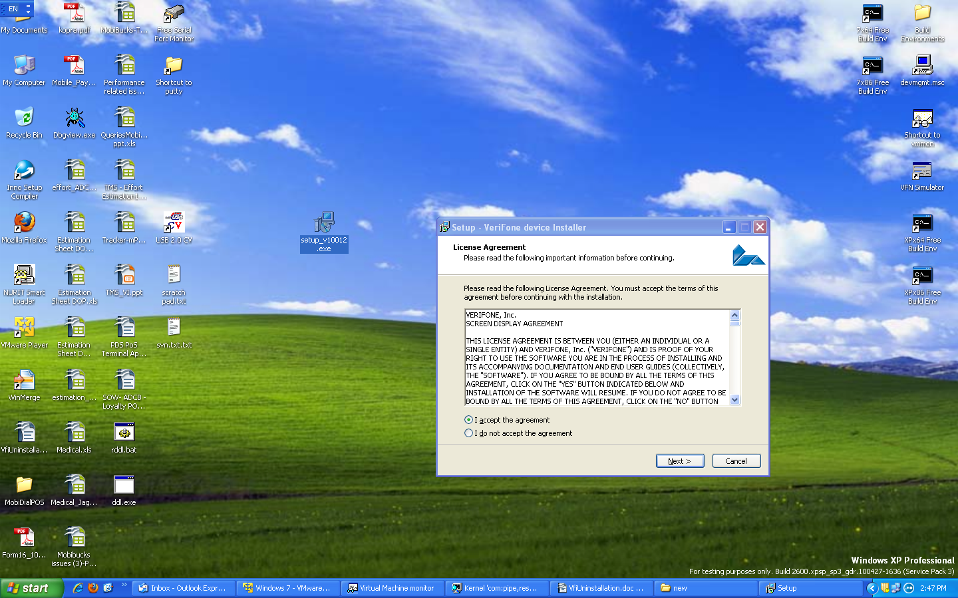

## Manual Installation using device manager

1. Connect the device to the PC, ensure the device is listed in the device manager: It will be shown as a new USB device with yellow exclamation mark.
2. Right click the device and select **update driver** option, select install from specific location (advanced) option
3. Select **Don't search. I will choose to the driver to install** option.

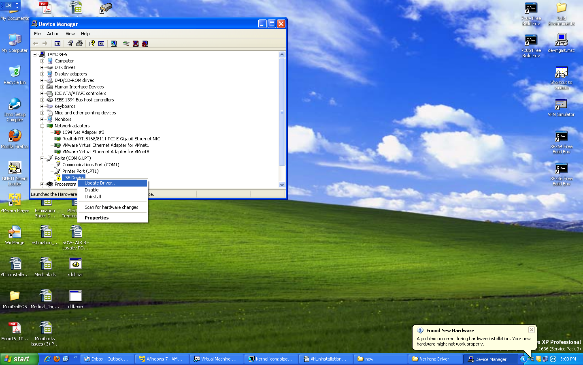

1. Select **Have a disk** option and provide the extracted folder path (ex. **C:\Program Files\VERIFONE\Vx USB Driver.**

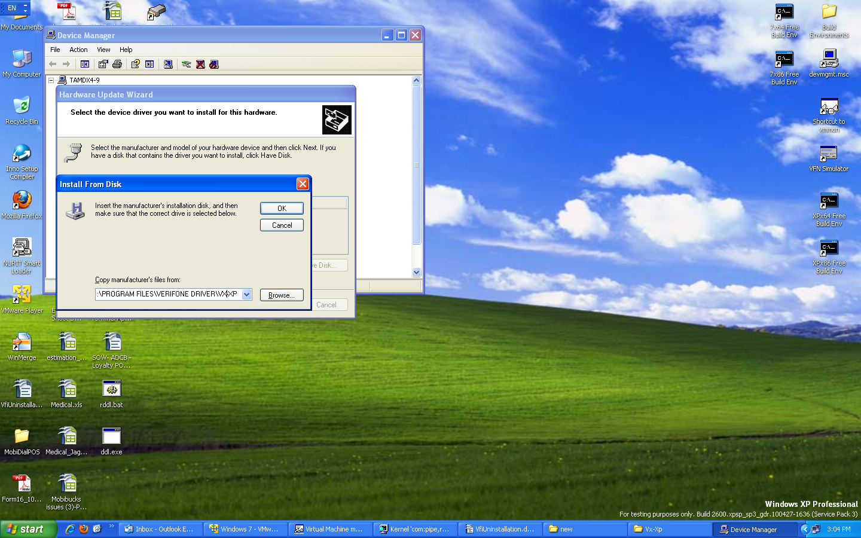

1. Click **OK** to proceed and complete the manual installation.

|  |  |
| --- | --- |
|  | * Vx-7 directory is selected if the PC used is Windows 7, 64/32 bit and the device is Vx. * PP-7 directory is selected if the PC used is Windows 7, 64/32 bit and the device is Pin-pad (Qx, PP1000, Nurit). |

# USB Driver Un-installation

## Normal Un-installation

1. Select the option sequence Start → Control Panel → Add or Remove Programs and Double click **VeriFone device Installer Ver. X.X.X.X.**

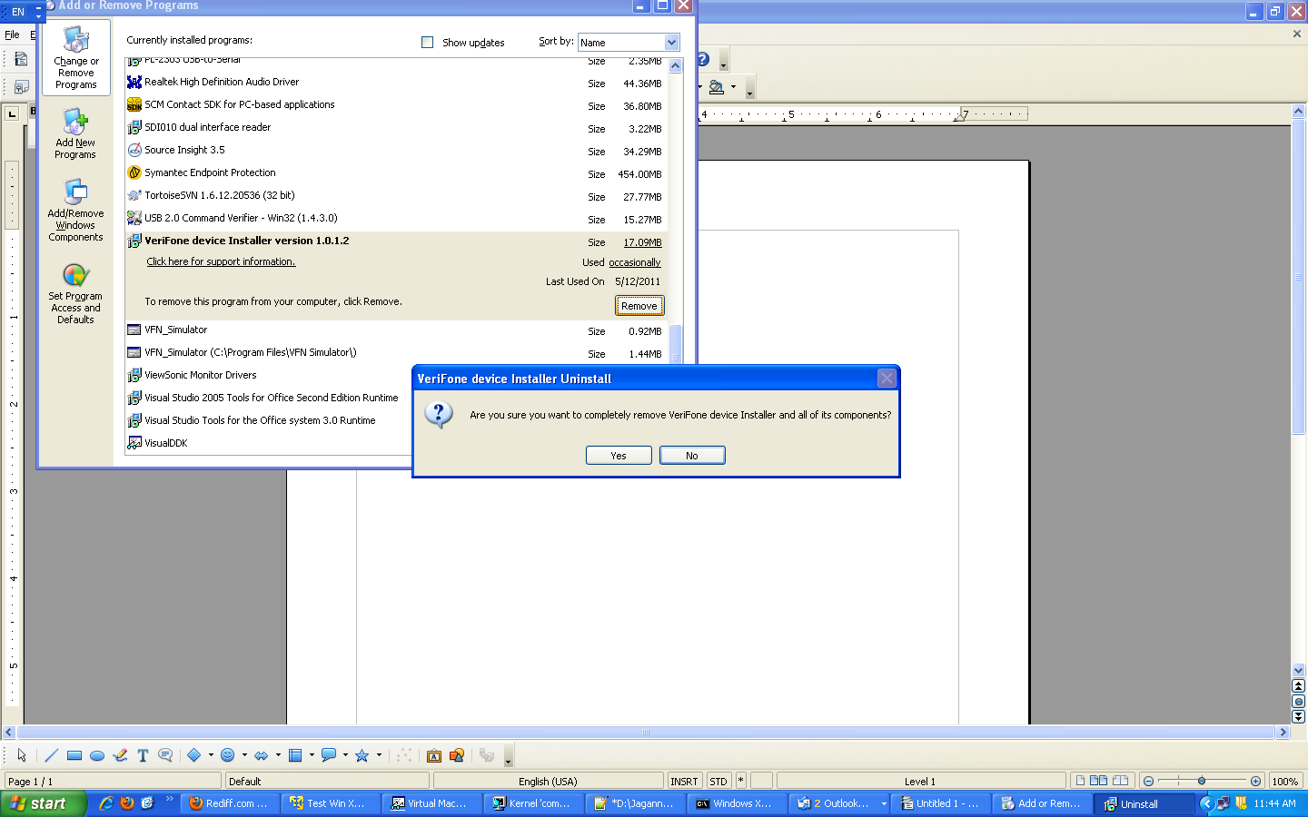

# Clean-up previously installed driver:

This section describes the procedure to clean up the previously installed driver before initiating the new installation of USB driver.

|  |  |
| --- | --- |
|  | It is recommended to follow the installation procedure explained in the above sections. Follow this Clean-up procedure only if the installation procedure mentioned in the above section fails. |

1. Repeat the un-installation procedure mention in the section **5.1, Normal Un-Installation.**
2. Go to **C:\WINDOWS\inf** directory
   1. Press F3 (to invoke search option, choose search companion).
   2. Enter details: Enter “*.inf” in the file-name box, “VeriFone” in the word/phrase box (without quotes).
   3. Search will provide the name of the inf file (Example: oem32.inf)
3. Delete the found inf file and corresponding pnf files (Example: oem32.inf & Example: oem32.pnf).

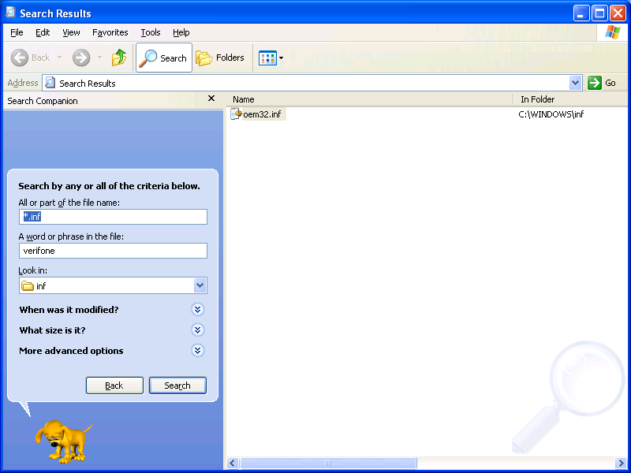

1. Before performing above step note down the corresponding .sys file present in the .inf file as shown below.
2. 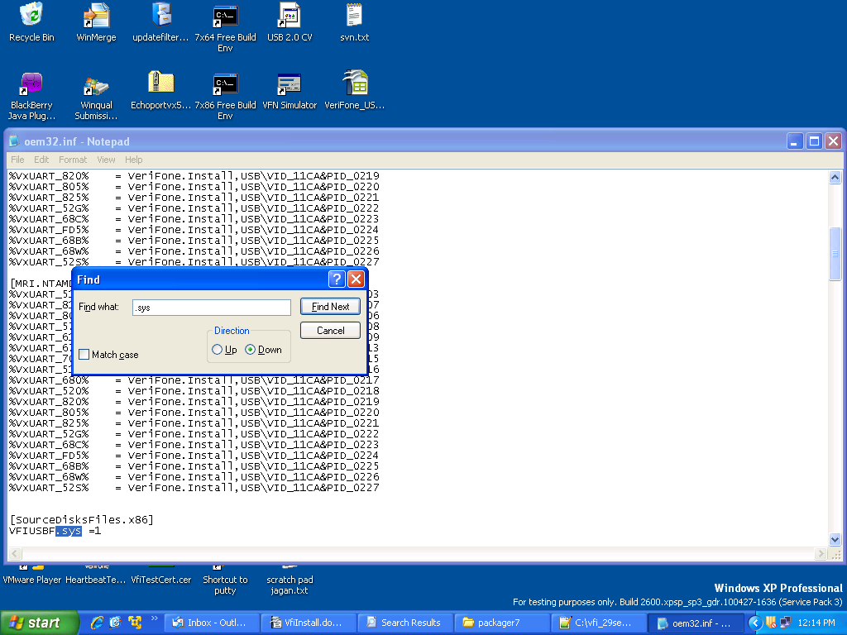Go to “C:\WINDOWS\system32\drivers” → delete the .sys file (Ex: VFIUSBF.sys & VfiEnum.sys).
3. Also check DRVSTORE dir (C:\WINDOWS\system32\DRVSTORE) for any folder which has the same .sys and inf file → If present delete the folder.

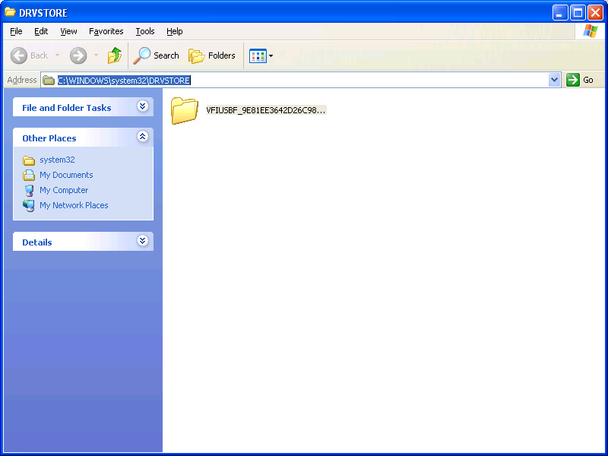

# Disabling Auto-update Option on WIN 7

To disable the option to download the drivers, select devices and printers from the start menu. Select the device with your computer name and right click, the context menu is displayed as shown below.

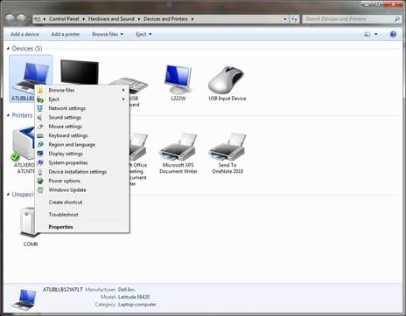

Select **device installation settings** option from the context menu. In the device installation settings window, select **No, let me choose what to do** option and then select **Never install driver software from Windows Update** option.

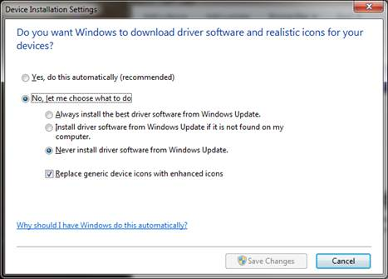

# Toggle Zero Writes

On some of the java applications that uses javax.comm package, which handles output data fragmentation before sending to driver, disabling the zero length writes are required.

The following steps are provided to explain the enabling and disabling the zero length writes( default behavior is enable)

* 1. Close all the applications using Vfi com port, disconnect the devices.
  2. Open command prompt(On windows 7,open the prompt with Admin privileges)
  3. Go To installed directory in C:\Program Files\VeriFone\USB Driver.
  4. Run “VfiUsbNoZeroWrite.exe 0” <-- set for zero writes OR Run “VfiUsbNoZeroWrite.exe 1” <-- disables zero writes
  5. Restore the device connections and start the applications.

# Com Port Properties

* 1. By default Windows allows usage of com port numbers up-to 255.
  2. V19 driver also supports com ports assignment up-to 255. Using default setup, com9 will be assigned, however user can choose to change the comport using SetVfiPort.exe utility from the command prompt.

Ex: Existing driver installed to use com port from com9 onwards.

However if one wants to use com ports starting from com 20:

* + Disconnect the device.
  + Invoke command prompt (in windows 7, invoke command prompt with admin privileges) go-to driver installed directory (C:\Program Files\VeriFone\Vx USB Driver)
  + cd C:\Program Files\VeriFone\Vx USB Driver
  + Execute the command “**setvfiport 20**” to assign from com 20.
  + Re-connect the device.

During certain scenarios like accidental power cutoff, comports resource will not be released by the driver, when power returns back, PC assigns next com-port to the device (ex: com9 is assigned before power-off and com10 after). In-order to regain the com9, user can perform below steps:

* + Disconnect the device
  + Invoke command prompt (in windows 7, invoke command prompt with admin privileges) go-to driver installed directory (C:\Program Files\Verifone\Vx USB Driver)
  + cd C:\Program Files\Verifone\Vx USB Driver
  + Execute the command “**ComReset.exe 9**”.
  + Re-connect the device.